Title: A Technical Seminar for DSS-G and Related GPFS Use
Author: Ray Paden (rpaden@lenovo.com)
Version: 2a, 10-11 June 2019
Schedule:
Monday, 10 Jun 2019: 9:00 AM – 12:00 PM, 12:30 PM – 5:30 PM
Tuesday, 11 Jun 2019: 9:00 AM – 12:00 PM, 12:30 PM – 5:30 PM
Abstract
This is a 2 day technical seminar based on the upcoming 2.4a release of DSS-G using Spectrum Scale 5.0.2 (aka GPFS). It will focus on 4 primary topics.
- Survey of DSS-G architecture and organization.
- Use of Spectrum Scale in a DSS-G environment.
- Major new features in Spectrum Scale 5.0
- Subblock architecture
- The mmvdisk command infrastructure
- Roadmap
While this seminar focusses on 4 key topics, in practice the topics will be largely intermingled. The presentations will be on a mixture of “slideware” and live demonstrations on a working system. Presentations will encourage interaction with the audience participation and abundant Q&A.
Note that the new mmvdisk command infrastructure is a core feature of Spectrum Scale RAID (aka, GPFS Native RAID or GNR); it provides a fundamentally different way for managing DSS-G storage compared to the legacy command structure. But the semantics of the commands will be familiar to experienced Spectrum Scale system administrators. The purpose of this command structure is to support new Spectrum Scale storage architectures within the same rubric as traditional Spectrum Scale storage architectures (which are not going away!). Over half a day will be devoted to this subject.

Part 1: DSS-G Architecture and Organization
- Architectural Overview:
- The DSS-G Product
- The GPFS Product
- GPFS Organization in a DSS-G Environment
- DSS-G Organization
- The New GPFS Subblock Architecture
- DSS-G Components
- Sample DSS-G Configurations
- The Role of Utility Nodes
Part 2: Using GPFS to Support DSS-G
Basic GPFS Architecture
- Pagepool
- mmcrfs -n
- System Admin Network
- Data Network (IP vs. RDMA)
- Multicluster: GSS/DSS-G storage cluster, GPFS client cluster
- Revisit Selected Utility Nodes: cluster manager, FS manager, quorum nodes, protocol servers
- Disk Lease Semantics (aka, “Heartbeat”)
- Quorum rules
- Configuration manager vs. CCR
- OS support (DSS-G is RHEL only; clients can run under other OS)
- GPFS components (mm vs. ts commands, GPFS Portability Layer, mmfsd, GNR)
- Networking Best Practices for DSS-G/GPFS
Configuring/Managing DSS-G/GPFS
- GPFS Client Cluster
- DSS-G Storage Cluster
- Multicluster
- The New mmvdisk Command Infrastructure
- Online Expansion Using mmvdisk Command Infrastructure
- Validating Performance
- GPFS Callback Utility
- Email Notification of Failed Disks
- Managing Expels
- Diagnostic Tools
- nsdperf,
- mmpmon
- benchmark tools (yaiobm, ior, iozone), mmdiag, mmfsadm (use with caution), gpfs.snap

Other Topics as Time Allows and Interest Dictates

Biographical Sketch
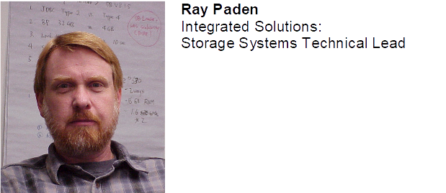

Dr. Ray Paden currently serves as the Storage Systems Technical Lead in Lenovo’s Integrated Solutions organization for the Distributed Storage Solution (DSS-G) product. He came to Lenovo in October 2014 with its acquisition of IBM’s System X organization where he served as an HPC Technical Architect with worldwide scope in IBM's Deep Computing organization, a position he has held since joining IBM in June 2000. His particular areas of focus include HPC storage systems, performance optimization and cluster design. Before joining IBM, Dr. Paden worked as software engineer doing systems programming and performance optimization for 6 years in the oil industry. He also served in the Computer Science Department at Andrews University for 13 years, including 4 years as department chair. He has a Ph.D. from the Illinois Institute of Technology in Computer Science. He has done research and published papers in the areas of parallel algorithms and combinatorial optimization, performance tuning, file systems, and computer science education. He has served in various rolls on the planning committee for the Supercomputing conference from 2000 to 2010. He is currently a member of ACM, IEEE and Sigma Xi. As a professor, he has won awards for excellence in both teaching and research. He has also received the Outstanding Innovation Award from IBM.

